**Stage 2:**

**GIT Repository :**

<https://github.com/thilaga123/capsule_task_manager>

username: Thilaga123

Password : 25Thila@gmail

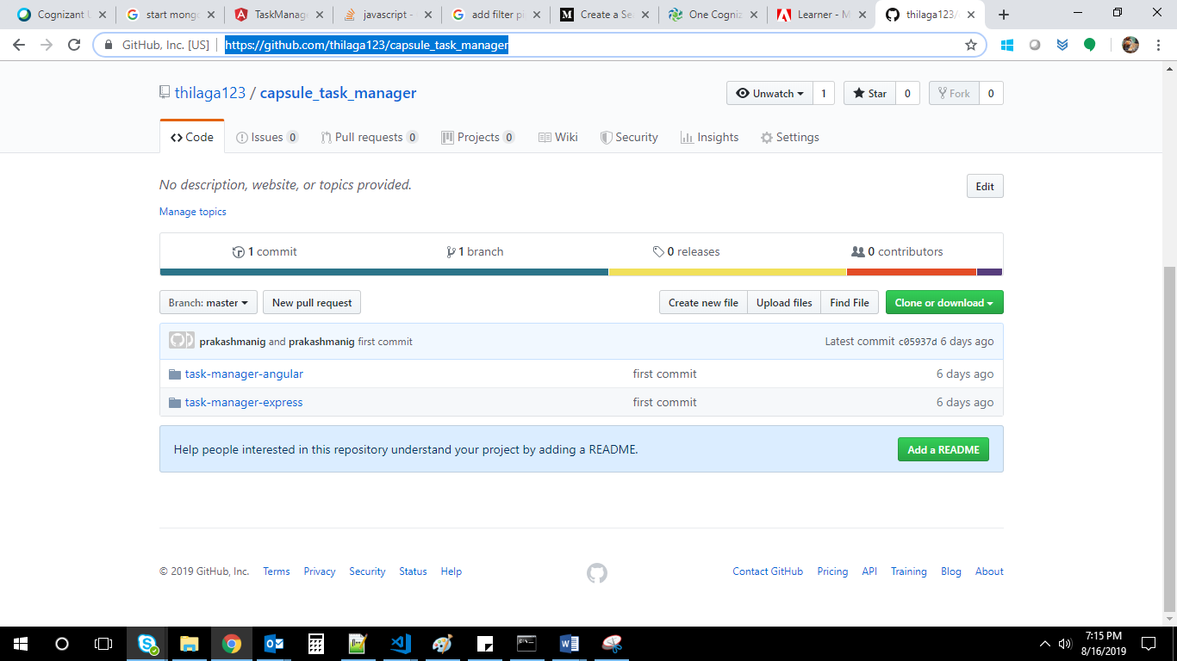

Task-Manager-angular for Angular project :

Task-Manager-express for node/express server :

**Working Screenshots :**

**Starting Mongo DB in port 27017:**

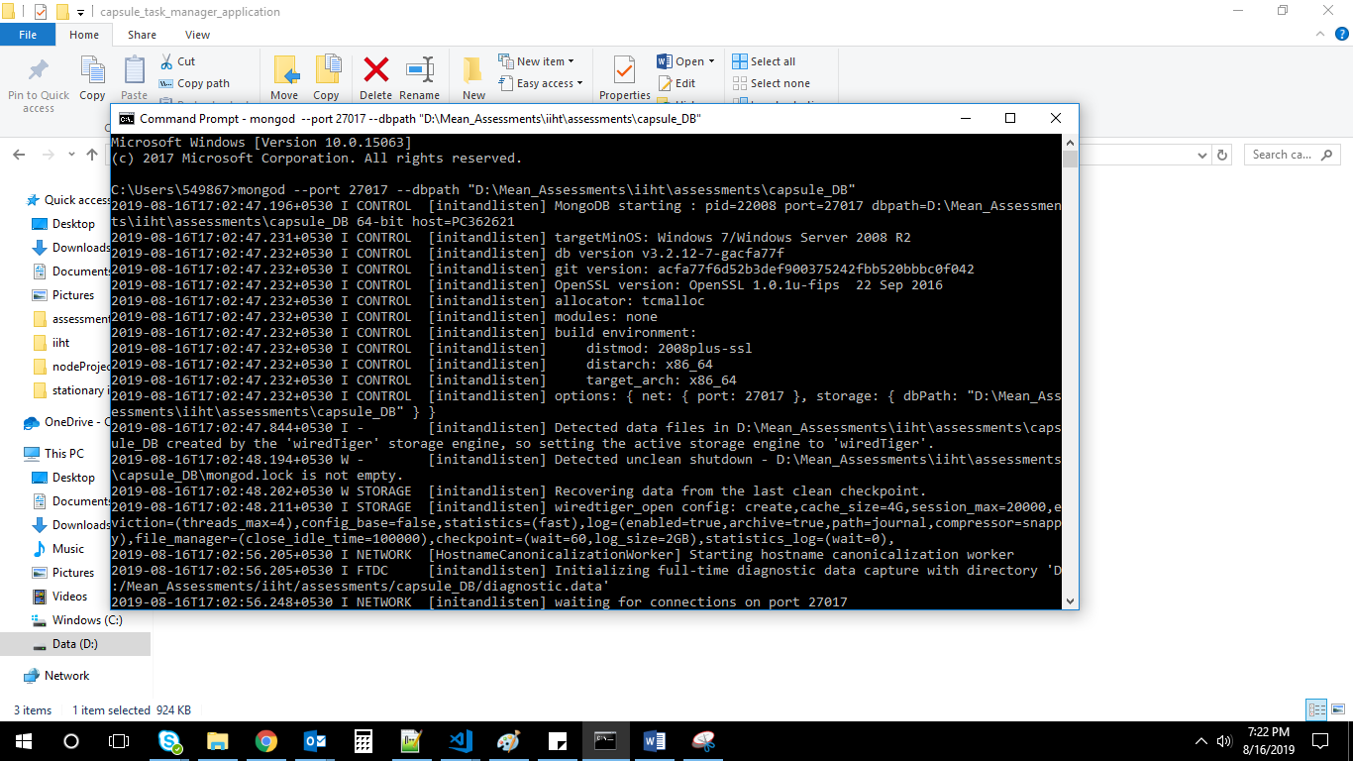

Starting Node server :

Navigate to Task-Manager-express path :

>Node server.js

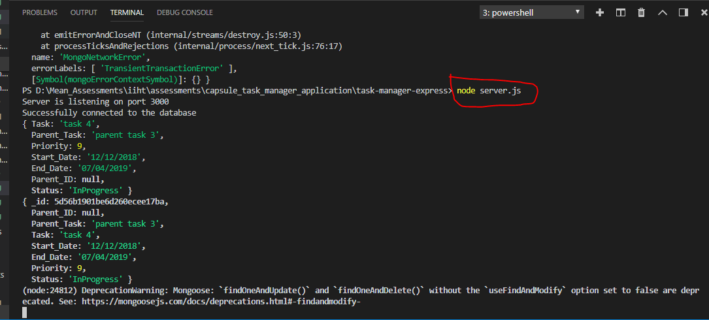

Start Angular :

>ng serve

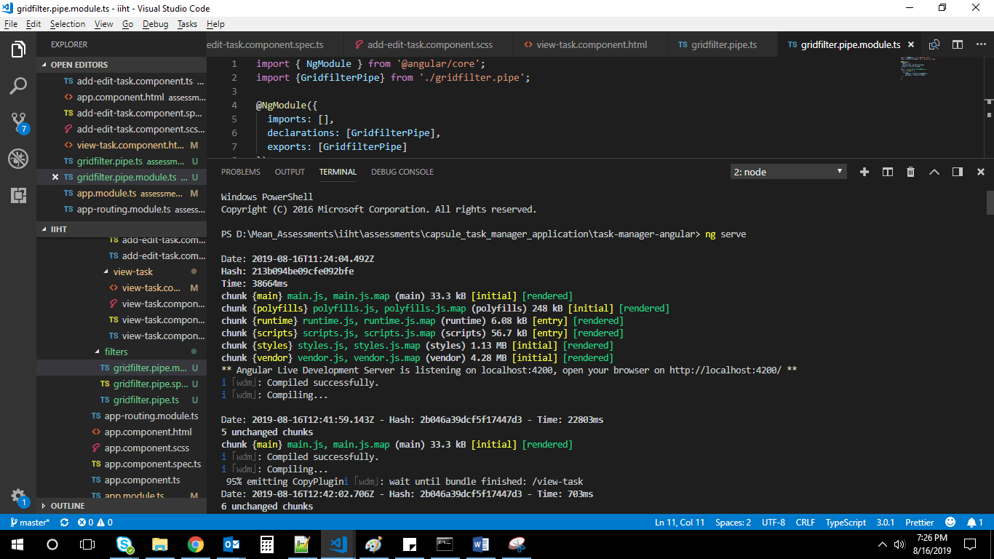

**ADD TASK :**

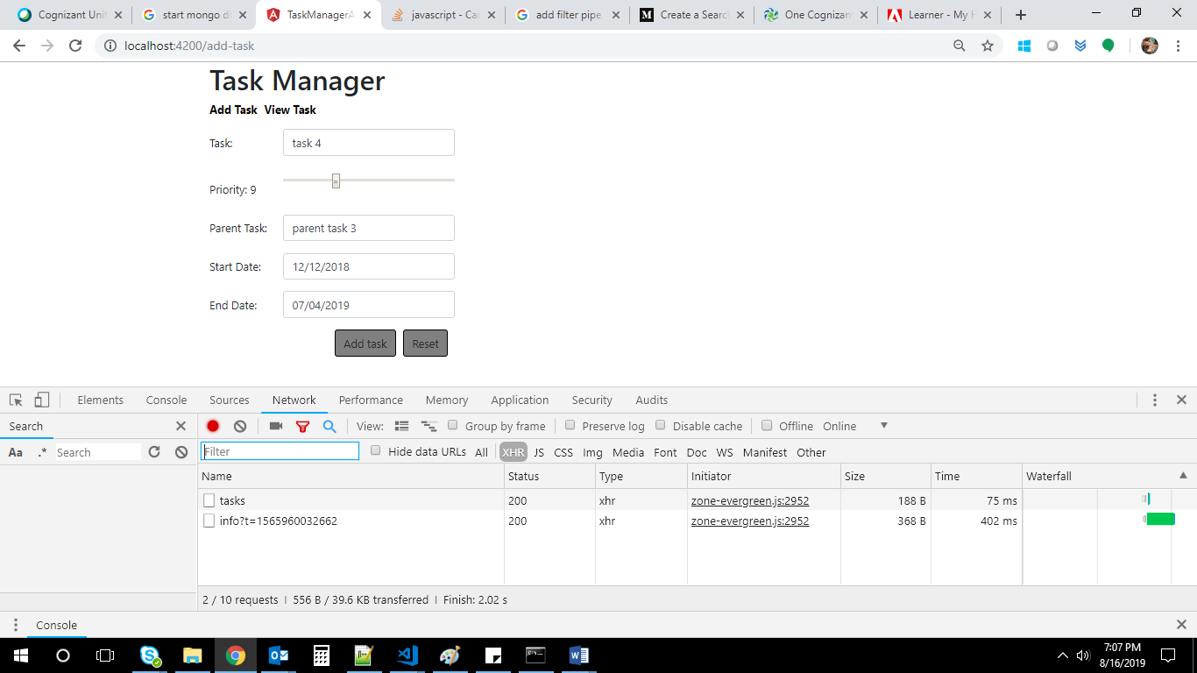

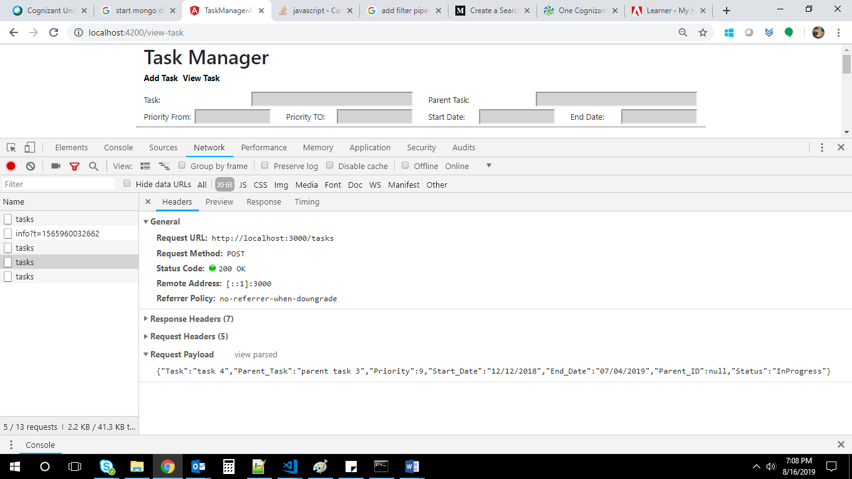

**Get all task :**

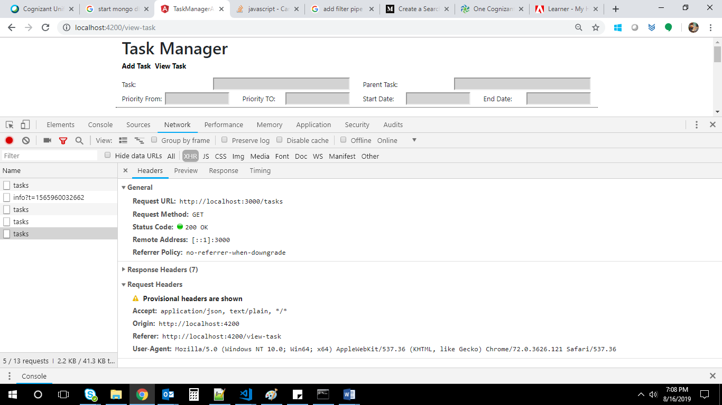

**response:**

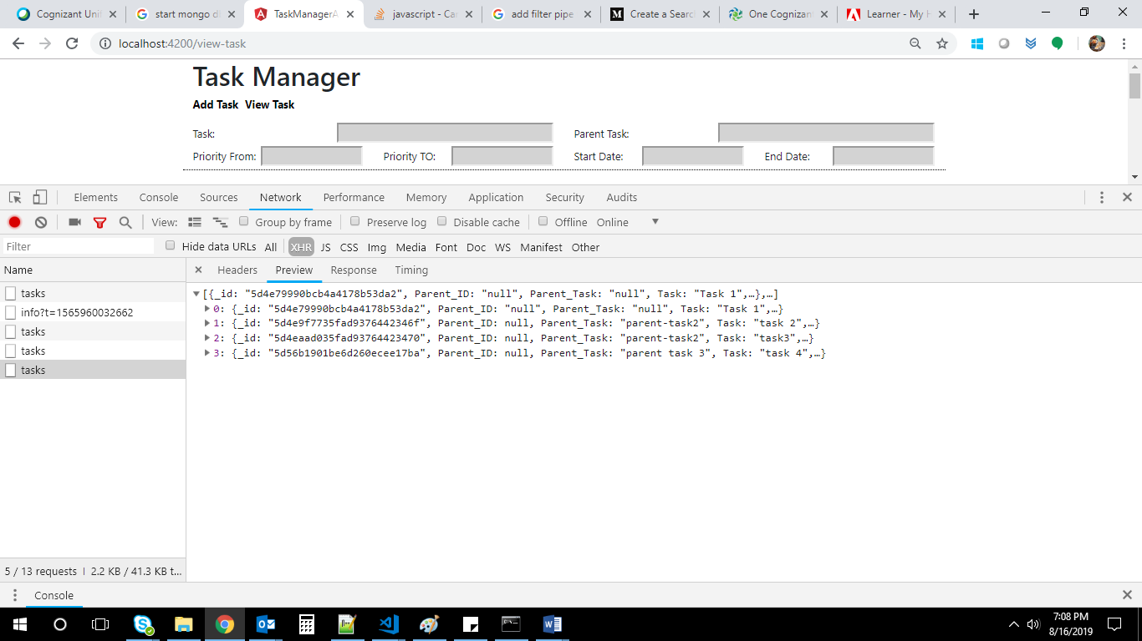

**View Task UI :**

